The role of indirect/chemical cues for community structure and species co-occurrence
The role of footprints and other interspecific cues for species coexistence

Project Description – Project Proposals

Dr. Florian Menzel, Mainz

Project Description

State of the art and preliminary work

Ant communities are usually structured hierarchically, with behaviourally dominant species at the top. These dominant species can aggressively displace others (the subordinate species) through direct behavioural interference (Parr & Gibb 2010). Some subordinate species are attacked by the dominants (‘subdominant’ sensu Savolainen&Vepsäläinen), others are ignored by them since they pose no threat (‘subordinates’ sensu Savolainen&Vepsäläinen). Ants have an elaborate nestmate recognition system, which enables them to discriminate their nestmates from non-nestmate conspecifics (refs), but also to distinguish between different species that are relevant to themselves (Menzel et al. 2008, Lang & Menzel 2011). This is used e.g. by subordinate species to avoid aggressive conflicts with dominant ones (Menzel et al. 2010a,b).
Recent studies indicate that ants do not only recognize each other upon encounter, but they also respond to indirect cues. These cues are usually chemical footprints, which closely resemble cuticular hydrocarbons (Binz et al. in revision; Akino& Yamaoka; Geiselhardt et al. 2010). They can be used by subordinate species to circumvent encounters with superior species. However, the appropriate reaction towards allospecific cues requires that an organism can assign the cues to the respective species. It is unknown up to now whether such cues are learnt by other species (refs?), or whether the reactions are innate and evolve through adaptation (Binz et al. 2013 Ethology, Lang & Menzel 2011). In any case, an alien species will be treated differently if it exhibits cues that do not resemble its native counterparts. This effect may play a major role for the invasion and establishment of alien species.
For predator-prey interactions, such effects, called ‘prey naïveté’ or ‘predator naïveté’, account for the success of invasive species in several cases (Sih et al. 2010). For example, an alien predator may not be perceived as dangerous by its native prey, and thus have a ‘novelty advantage’ from the prey being naïve (EICA). Similarly, alien prey may not be recognised as prey by native predators, leading to the ‘enemy release’ effect (ref). The ant species of a community are competitors, but they also prey on each other (intraguild predation, ref.). A native species that does not avoid an invasive, superior competitor thus risks being displaced from resources or even being eaten.

In the proposed project, we aim to investigate how indirect chemical cues influence interspecific interactions in ant communities.
Our general prediction is that the reactions of different species to the cues match their competitive ability (inferior species are approached or ignored; superior species are avoided).
Studies report that NCE may even exceed CE (Sih et al. 2010, refs Metaanalysen und Reviews).

General outline of the introduction:
Many ant species coexist, although it is still unknown how they avoid competitive exclusion.
niche partitioning does not fully explain it

spatial structure could enhance coexistence if submissive species use territories unoccupied by dominant species.
A recent study showed that submissive ants avoid cues of dominant species, linked to a dominance hierarchy. This is analogous to antipredator behaviour based on chemical cues, which has been shown in many taxa.

But. intraspecific variation in ‘competitiveness’ varies strongly (at least in ants).

But. may be learned or innate.

In the proposed DFG proposal, we plan to study the influence of cue responses on the spatial distribution of nests.

Susannes personality traits (Vorschläge Juni 2015): aggression; exploration (1 open field-> activity; 2 novel objects); activity
recruitment (=tendency to lay trail pheromones??); communication, phototaxis. Nur Fourageure nehmen!

Previous work
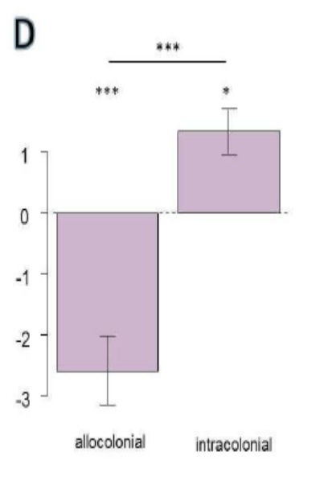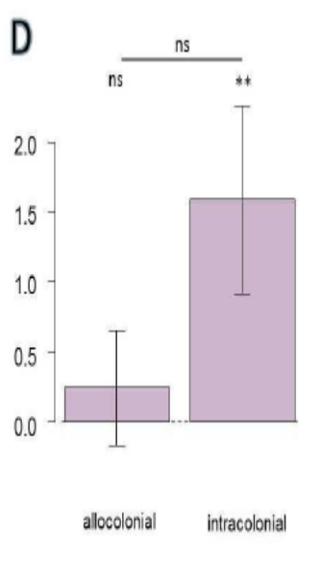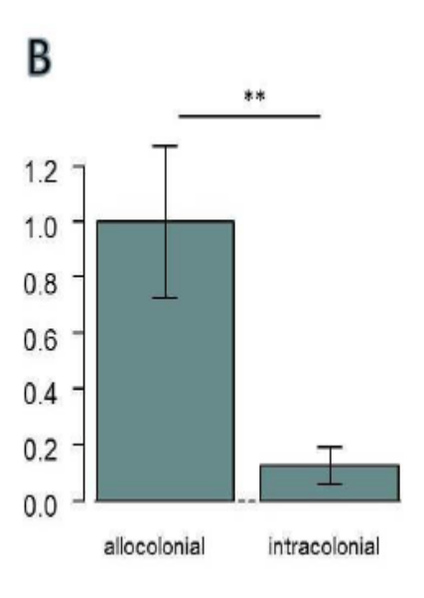

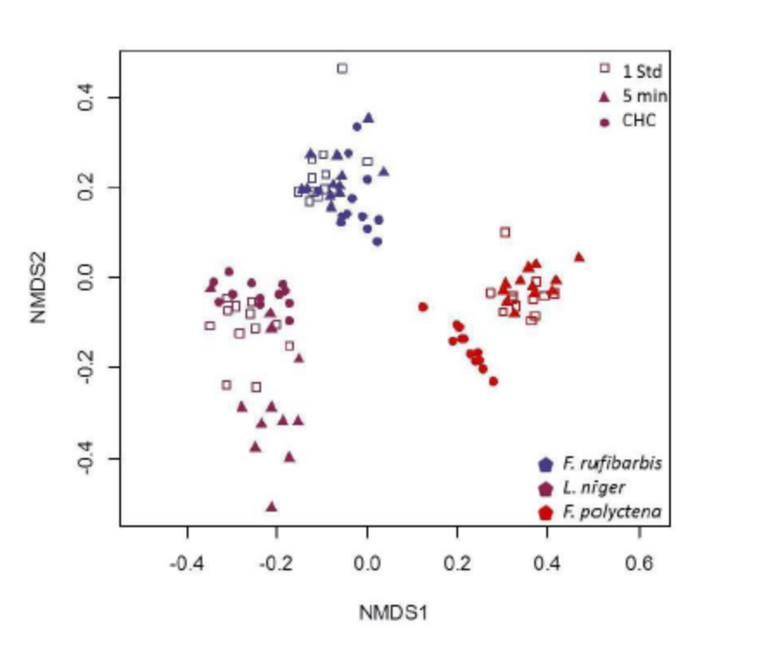
Fig. 1 left (D) Lasius niger response to allocolonial and intracolonial footprints (conspecifics). Negative values are avoidance, positive ones are following.
middle (D) Tetramorium caespitum response to allocolonial and intracolonial footprints.
right (B) Formica polyctena, antennation frequency
Fig. 2 Footprints and cuticular hydrocarbons of three Formicine ant species.
Previous studies showed that several ants can discriminate intra- and allocolonial footprints.
Several ant species followed intracolonial footprints. However, only one species (L. niger) significantly avoided allocolonial footprints. Some species did not show differential behaviour, but antennated allocolonial footprints more frequently, indicating that they perceived the difference. Some ant species (Myrmica rubra, Formica polyctena) indiscriminately followed intra- and allocolonial cues.

Aphids react to ladybird footprints (Ninkovic 2013); slugs react to carabid cues (Bursztyka 2013); spider mites react to predatory mites (Bowler et al. 2013)

Project aims
Species to be studied: Lasius niger, Myrmica rubra, Formica rufibarbis, Formica polyctena, Tetramorium caespitum, Temnothorax nylanderi. (evtl. noch andere)

Aim 1: Ecological role of footprint responses
Aim 1a: What is the relative importance of direct consumptive / competitive effects (CE: aggressive displacement) versus effects of indirect cues (NCE – non-consumptive effects)? (in analogy to consumptive and non-consumptive effects, i.e. antipredator behaviour, in predator-prey interactions)

Welchen Einfluß haben diese Reaktionen auf das Fouragierverhalten, im Verhältnis zu direkter Aggression?
- Können Aggressionen durch Reaktion auf Fußspuren vermieden werden?

Predictions:

interspecific
- Ants use cues of sympatric species adaptively: they avoid cues of aggressive species, and tolerate/follow those of non-aggressive/inferior species
- Ants can be conditioned (as a group).
- Ants distinguish between cues from different species.

intraspecific
- Differentiation between intra- and allocolonial depends on cue similarity and intercolonial aggression.
- Dear neighbour: Ants can habituate to certain footprints.
- Ants can be trained to avoid certain colonies.--> possibility to discriminate different alien colonies!

Differenzierung: Nutzung von arteigenen, koloniefremden Signalen vs. Nutzung von artfremden Signalen

Experimental setup
for quantification of the effects of direct interaction vs. chemical cues (compare to consumptive effects vs. non-consumptive effects, Sih et al. 2010)

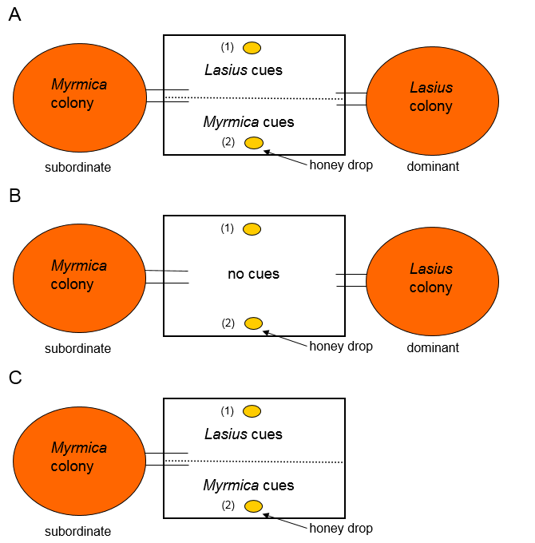

A: chemical cues and direct interaction
B: direct interaction only (not entirely)
C: chemical cues only
Prediction: If subordinate species (e.g. Myrmica) use cues to avoid aggression, then
a) dominant aggression in setup A (bites of Lasius towards Myrmica) should be lower than in B.
b) Myrmica should avoid the area covered with Lasius cues (number of workers on the area at 10 scan sampling times) in A, whereas no difference should occur in B.
c) Myrmica should recruit more strongly to bait (2) than to bait (1) in A, but not in B.

The effect will be quantified as a ratio of cue-mediated and non-cue-mediated effect. This value denotes the relative effect of the chemical cues on foraging decisions.

Quantification of effect size:
a) A: 60 bites, B: 80 bites → cue effect is (80-60)/80=0.25
b) A: 30 vs 10 workers (25% in cue area); B: 20 vs 20 workers (50% in area). Effect size: 50%-25%/50% = 0.5
c) A: (1) 10, (2) 30 workers; B: (1) 20, (2) 20 workers. Effect size as in b).

Aim 1b: Do footprint responses vary consistently among species and colonies, according to their local dominance rank? [field]
Intraspecific competition asymmetries: do inferior colonies avoid footprints of neighbouring, superior colonies?
These mechanisms are more likely to happen in species that compete with others (Lasius, Myrmica, Formica) compared to those who do not compete as strongly (seed-eating Tetramorium, Lasius flavus, Solenopsis fugax).

Experimental design:
20 colonies per species are tested in the field (each colony: 10 workers on the same Y maze)
against every other species?
eg. F. rufibarbis against FC of a neighbouring and of a distant Lasius colony
plus against FC of a neighbouring and a distant conspecific colony

Footprint following should match aggression tests (conducted in an arena directly in the field). → inferior species should avoid prints, superior ones ignore or follow them.

Aim 1c: Do footprint responses correlate with spatial distribution of colonies? [field] – muss noch ausgearbeitet werden
- large colonies should be more prone to follow foreign footprints, and less prone to avoid them
- colonies should show stronger avoidance of footprints of neighbouring species (if they are superior) than of unknown species.
- intraspecifically: colonies should show stronger avoidance of neighbouring conspecific colonies than of unfamiliar conspecific colonies. (home-range marking!)
- if neighbouring colonies (of diff. species) fight, then only one species (or none) should follow the other's footprints. The other colony should avoid the footprints of the first colony. I would not expect that both colonies follow each other's footprints.

collaboration with Dr. von Mammen: Which patterns are generated when footprint responses can be learned vs. when they are not learned?
Ants leave footprints that evaporate very slowly. → around the nest, there is a "Hof" with decreasing footprint density with nest distance. A founding queen comes in. Simulate heterogeneity in habitat quality (nest establishment success rate varies spatially). → under that condition, an ant queen benefits from following conspecific footprints → high probability of finding a good habitat patch.
- scenario A: all ants follow footprints of other colonies
- scenario B: all ants ignore footprints of other colonies
- scenario C: all ants avoid footprints of other colonies
- scenario D: ants follow footprints first, but learn to avoid them upon aggressive encounter
Test: How do Lasius founding queens react to footprints?

Aim 2: Behavioural development of footprint responses: Can the response to cues be learned?
- naive Kolonien: reaktion auf intra-/allocoloniale Fußspuren (intraspezifisch)
- 1) Test auf Reaktion
- 2) Konditionierung mit
    - 1) fremden lebenden (→ Aggression; die fremden werden negativ assoziiert)
    - 2) fremden toten (→ Gewöhnung, der fremde Geruch hat keine Konsequenzen → dear-neighbour effect)
    - 3) Kontrolle: tote, abgewaschene Ameisen
[jeweils getrennte Koloniefragmente]
3) Wiederholung des Versuchs nach 1 Tag (oder wenigen Stunden): short-term conditioning
4) Wiederholung des Versuchs nach 1 Woche (long-term memory)
Setup:
12 colonies of the tested species will be divided in three fragments (each with workers and brood) A,B,C
A fragments: confronted with living workers of a dominant species (→ tested species is competitively inferior, will be attacked, avoidance necessary)
B fragments: confronted with dead workers of a dominant species (→ habituation, no avoidance necessary)
C fragments: control; confronted with nobody (→ no “training” or “conditioning”)

Further combinations of tested and “confronted” colony:
tested: Lasius niger; confronted with:
- alien, conspecific colonies (from a different site, at least 500m away!)
- six sympatric, superior species; (F. polyctena)
- six sympatric, inferior species; (M. rubra, L. flavus, T. caespitum, F. rufibarbis, S. fugax)

One can evaluate
- the role of positive and negative conditioning on the cues response for each confronted species
- whether conditioning has a stronger effect if the confronted species is a superior one (stronger selection pressure / stronger damage)

Is the response lost over time (do ants forget)? Repeat experiments after 1 week

Aim 3: Footprint response as a personality trait: The role of intraspecific variation in footprint responses
Aim 3a: Do footprint responses correlate with other behavioural traits (exploration, aggression)?

Following interspecific (or allocolonial) footprints can be seen as an ecologically highly relevant form of explorativeness.

Aim 3b: Do personality traits differ between neighbouring colonies more than expected from random?

Does
Do footprint responses vary consistently among conspecific colonies, i.e. are they a personality trait? Is this trait related to other colony traits (size or personality traits like aggression, exploration)? [field]
Is the outcome of interspecific encounters (i.e. aggression) predictable from footprint reactions?
Interesting: Lasius differentiates between intra- and allocolonial footprints, and shows high intercolonial aggression. Myrmica does not differentiate between footprints, and shows low intercolonial aggression.

Aim 4: Do personality differences among ant colonies predict their spatial distribution?
Prediction 4a: Intraspecific colony distribution
We expect that colonies with similar personality compete more strongly than those with different personality. Thus, neighbouring colonies should differ in their personality more than random (Wolf & Weissing TREE 2012). For example, bold colonies should have shyer neighbours. Colonies with high phototaxis should be neighbouring to ones that have a lower phototaxis (and thus forage predominantly at night/dusk/dawn). More explorative colonies can be more efficient in finding new food resources, and thus suffer less if they are displaced from other food sources by aggressive neighbours (assuming that exploration and aggression are negatively correlated - not sure).
Personality traits: aggression, exploration, following response to foreign footprints (follow or avoid). Possible further traits: daily activity rhythm (temporal "niche partitioning" within a species), temperature preferences.
This is testable with
-Temnothorax nylanderi (high population density, spatial distribution is recorded, each colony is tested in the lab)
-Lasius niger (high population density, spatial distribution is recorded, colonies are tested in the field)
- Formica rufibarbis
- Myrmica rubra
- Formica polyctena (need to find a large forest patch with high population density) → forest near Alzey
Problem of polydomous colonies (control for that by determining colony identity with population genetics?)
This is also testable with wolf spiders - highly abundant, easy to catch alive (pitfalls → record location of capture), easy to identify and to keep in the lab; personality traits can be determined.

4a-2: further intraspecific niche differentiation
→ regarding food preferences (oleic acid, protein, sugar)
→ regarding stable isotopes
→ regarding fatty acids

Prediction 4b: Among ecologically similar species, personality differences are more important than interspecific differences for the spatial distribution of colonies
E.g. a site near Freiburg with Myrmica rubra, M. ruginodis and M. sabuleti - personality should be more important for the outcome of competitive interactions than interspecific differences.
In meadows near Mainz, personality differences between Lasius niger, Formica rufibarbis and Formica cunicularia may be more important in competitive interactions than interspecific differences.
Thus, personality differentiation can be a coexistence mechanism that enables long-term coexistence of species!

Side questions

Side question 1: The importance of cue similarity
Can ants distinguish between cues of different species (choice between Myrmica cues vs. Formica cues instead of Myrmica cues vs. cue-free)
How about cues of other taxa, e.g. spiders?
Relate reaction to chemical cue similarity and to cue quantity (absolute amount of footprints)
Reaction should be stronger if cues of an unknown species are similar to a known one. (related species? M. rubra / M. ruginodis → different cues, but related species → IIb-Praktikum)
Are cues learned better if they are more similar to the own species’ cues?

Side question 2: The role of co-evolutionary history.
Can cues of sympatric species be learned better than of allopatric cues?
would indicate relevance of co-evolutionary history

